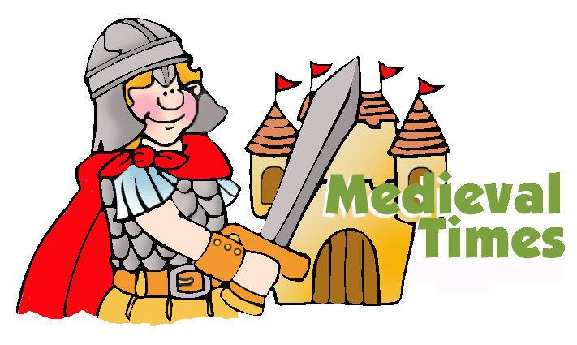
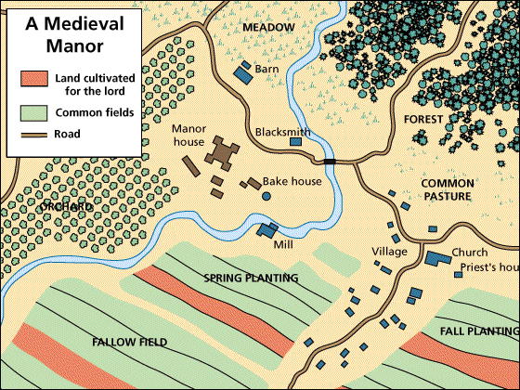
Grade 5 - Social Studies
Social Structure in the Middle Ages
Create a Game
Project due: May 4th

Map
Create a map showing the three social orders in the Middle Ages: Nobles, Clergy and Peasants.
- The map should have an area that will show how each of the orders lived and worked. Map should be on a 8 ½” x 17” given out in class.
- Include a legend to tell the reader what the symbols on your map mean.
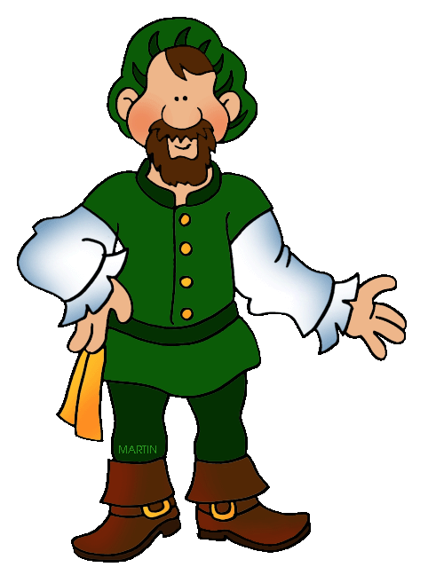
- Can have parts the are 3-D, like houses or castle, but must be able to fold down for storage.

People
Create paper people (paper dolls) that represent each of the social orders.
- Draw clothing that will show each of the orders dressed, example king, knight, priest, nun, bishop, blacksmith, farmer etc.
- You must have at least 5 people (you can have more) there must be at least one person from each order.

Game
Using your map as the board, create a game using the people you created as game pieces.
- You can use a board game you are familiar with to create your own game with a Middle Ages theme. You must create all the parts of your game, do not use parts or pieces of a game you own. Unless approved by your teacher.
- Create came cards or directions on your board for the players to follow.
- Create rules to tell your classmates how to play the game. The rules must be written clearly, outlining the procedure or steps to follow to play the game. As well as, number of players, who has the first turn and how the winner is determined.

Important Notes:
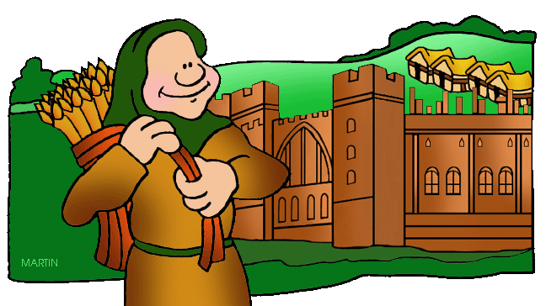
- Use the information in your text, Chapter 3, to help you create your project. You can also use some of the books we have in our class and the Internet.

- Your entire project should be contained in a large ZipLoc bag.

- You can choose to make a different type game, ie memory game with cards. However, your game must include details as outline above.

- If you are not sure please discuss your ideas with your teacher.

